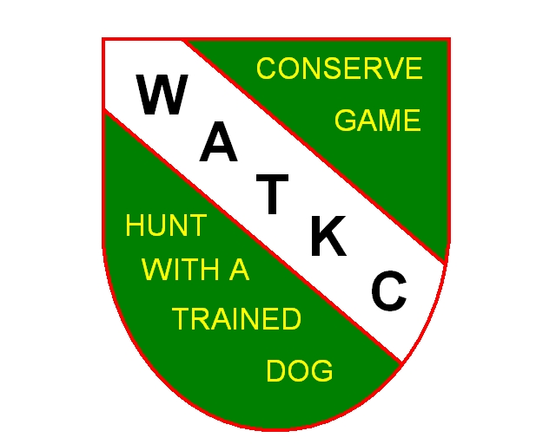

**WEST ALLIS TRAINING KENNEL CLUB**

**MEMBERSHIP APPLICATION**

Name: (please print) ______________________________________________________

Address: __________________________________City________________________Zip______

Phone: _______________________________

E-mail: _________________________________________________________________

I hereby apply for membership in the West Allis Training Kennel Club (WATKC). I understand that upon my acceptance, I will be required to pay a combination of initiation fees and first year dues totaling **$265.00**. Annual dues are currently $465.00 but members can work on Club Committees or at Club functions for up to 30 hours per year and reduce the annual dues to $165.00. Credit is given for all work hours performed at the rate of $10 per hour to a maximum of 30 hours. Work performed in your first year of membership is credited to your second-year dues payment. Work hours are not transferrable except upon approval by the board. (New member applications approved after August 1 receive a 50% reduction in membership fee and a 50% reduction in that year’s work hour requirement.) Dues amount and work credit rules are subject to change by WATKC Board of Directors.

I certify that I am at least 18 years of age and if accepted as a member, I agree to abide by the By-laws and Rules and Regulations of WATKC.

Applicant’s signature: __________________________________________ Date: ______________

Dog Breed: ________________________________

**_____________________________________________________________________________________________**

In applying for membership in WATKC, the Club assumes you are interested in becoming an active member and that you will want to participate on Club Committees and at Club functions. Listed below are Committees and club functions that are essential to the operation of WATKC. Please indicate any areas you would be willing to assist.

Grounds ______ Equipment ______ Clubhouse Maintenance ______

Jamboree _____ Hunt Tests ________ Field Trials________

|  |
| --- |
| Date App Received:____________  Accepted for Membership:______________  Notice Sent: ______________  Response: ________________  WATKC Use Only |

Send completed application to Membership Chairperson:

Tom Mueller Email: winddancer.rtrvrs@hotmail.com

2534 N. 71st Street

Wauwatosa, WI 53213 . Phone: 414-852-7261